ASP.NET Core Web API – Hands-on 3
Aim
To create an ASP.NET Core Web API that returns custom model objects and implements Custom Authorization and Custom Exception filters.
Theory
- Custom Model Class: A custom model class represents application data using C# objects.
- HttpGet: Retrieves data from the server.
- FromBody: Reads the request body and binds it to a model object.
- Action Filter: Intercepts incoming requests before an action method executes.
- Exception Filter: Handles exceptions globally and returns appropriate error responses.
- AllowAnonymous: Allows an action method to be accessed without authentication.
Procedure
- Created a new ASP.NET Core Web API project.
- Created Models and Filters folders.
- Created Employee, Department, and Skill model classes.
- Created EmployeeController with GET, POST, and PUT action methods.
- Implemented the private GetStandardEmployeeList() method to return a list of employees.
- Used the FromBody attribute in POST and PUT methods.
- Added ProducesResponseType for HTTP status codes.
- Tested the GET API using Swagger.
- Created CustomAuthFilter to validate the Authorization header.
- Applied the Custom Authorization Filter to the EmployeeController.
- Created CustomExceptionFilter to handle exceptions globally.
- Logged exception details to ExceptionLog.txt.
- Registered the Custom Exception Filter in Program.cs.
- Tested the Authorization Filter and Exception Filter using Swagger.

EmployeeController.cs
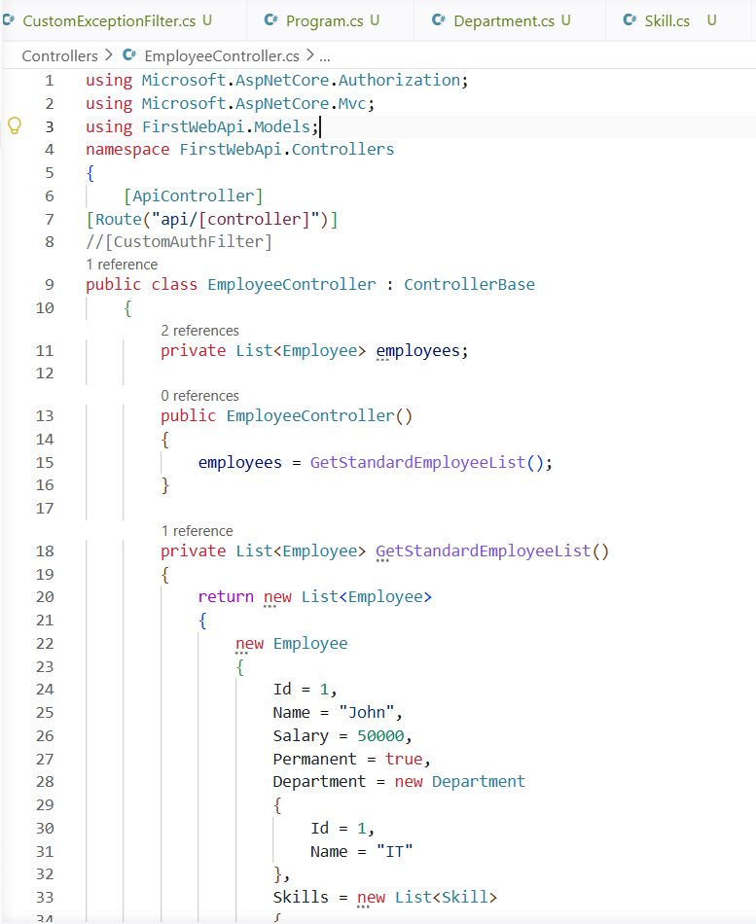
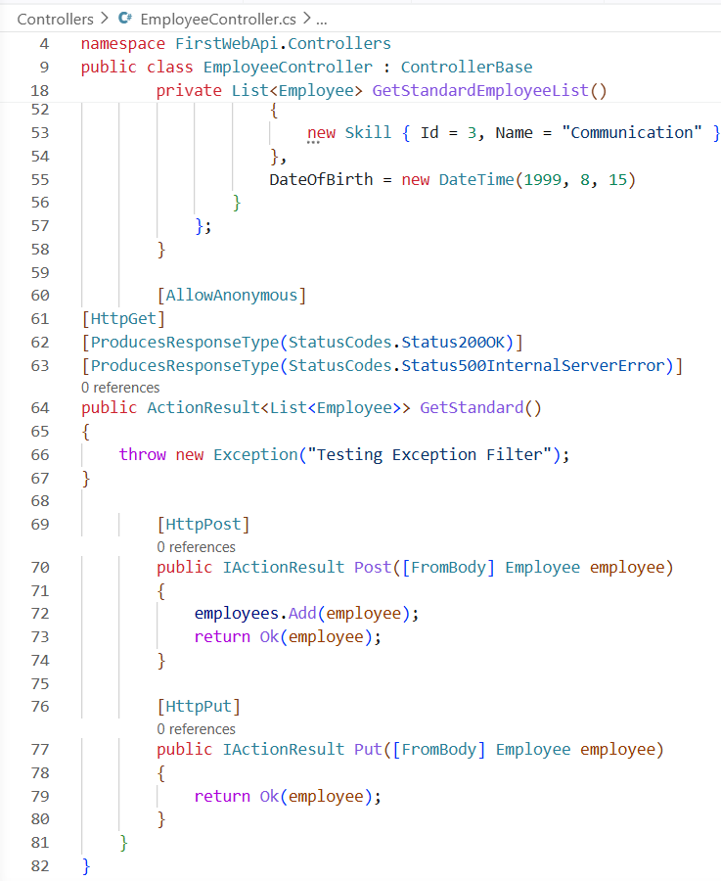

GET API – Employee Details Retrieved Successfully
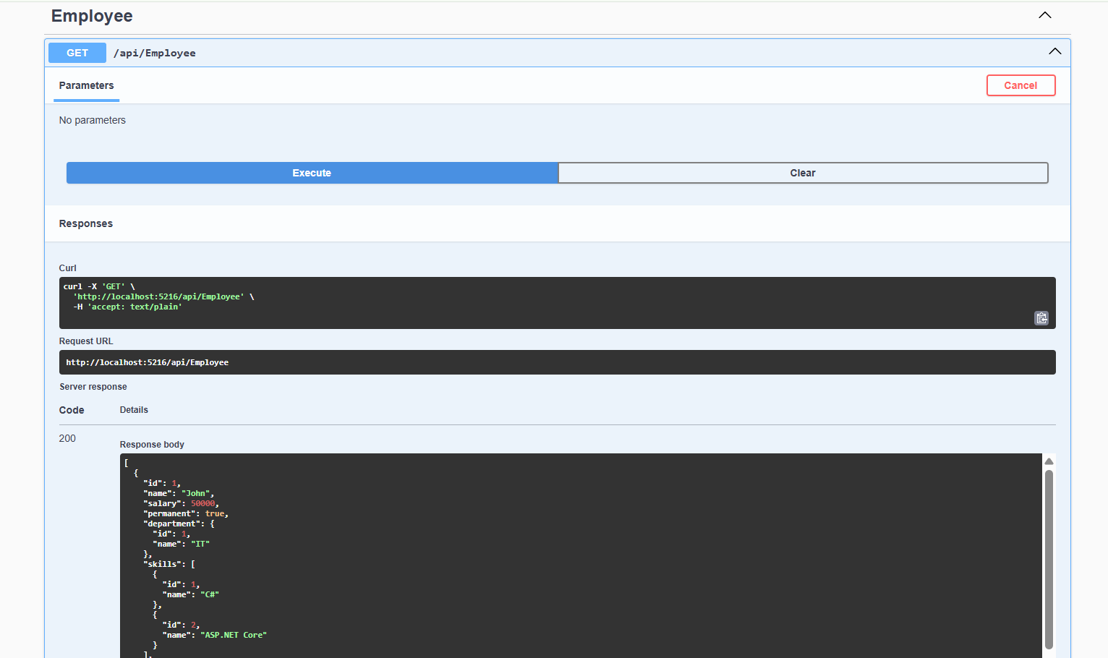
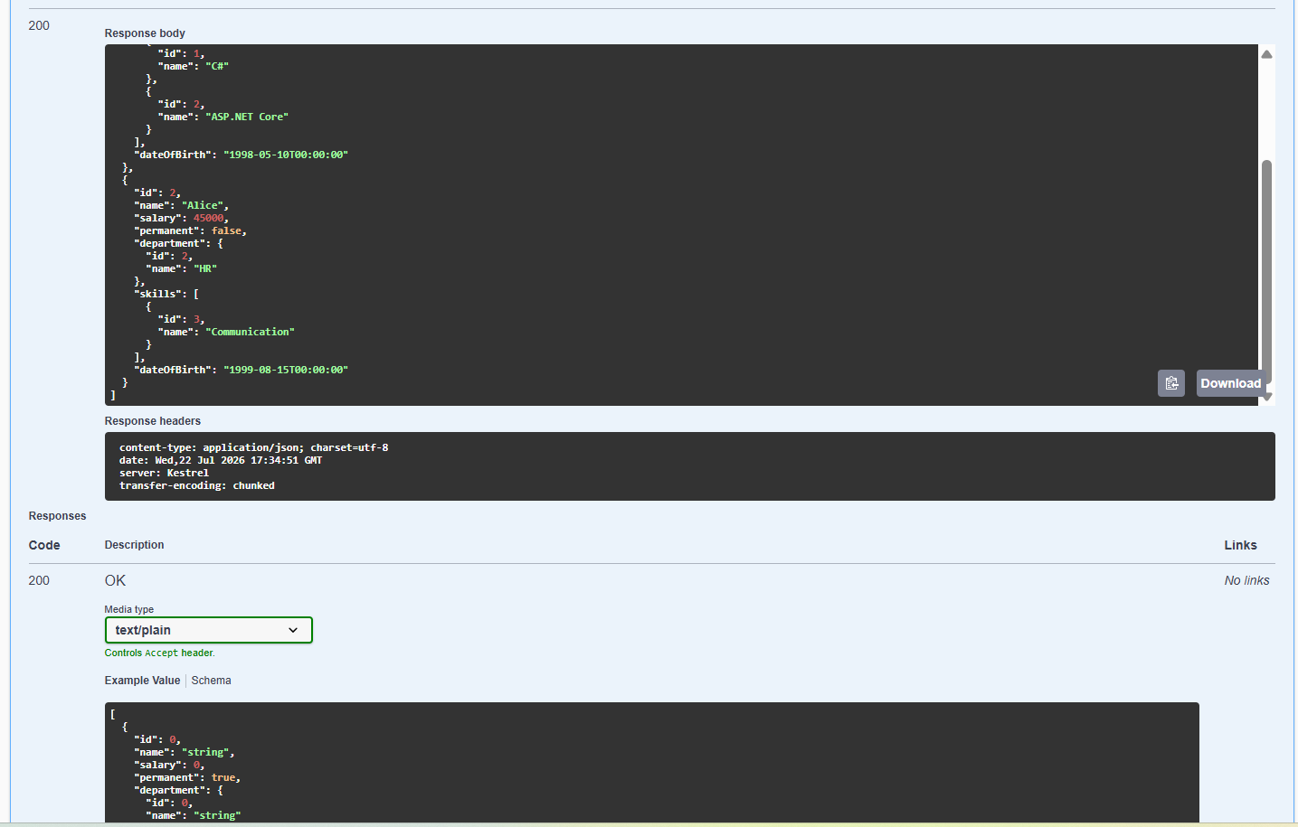

Authorization Filter – Invalid Request (No Auth Token)
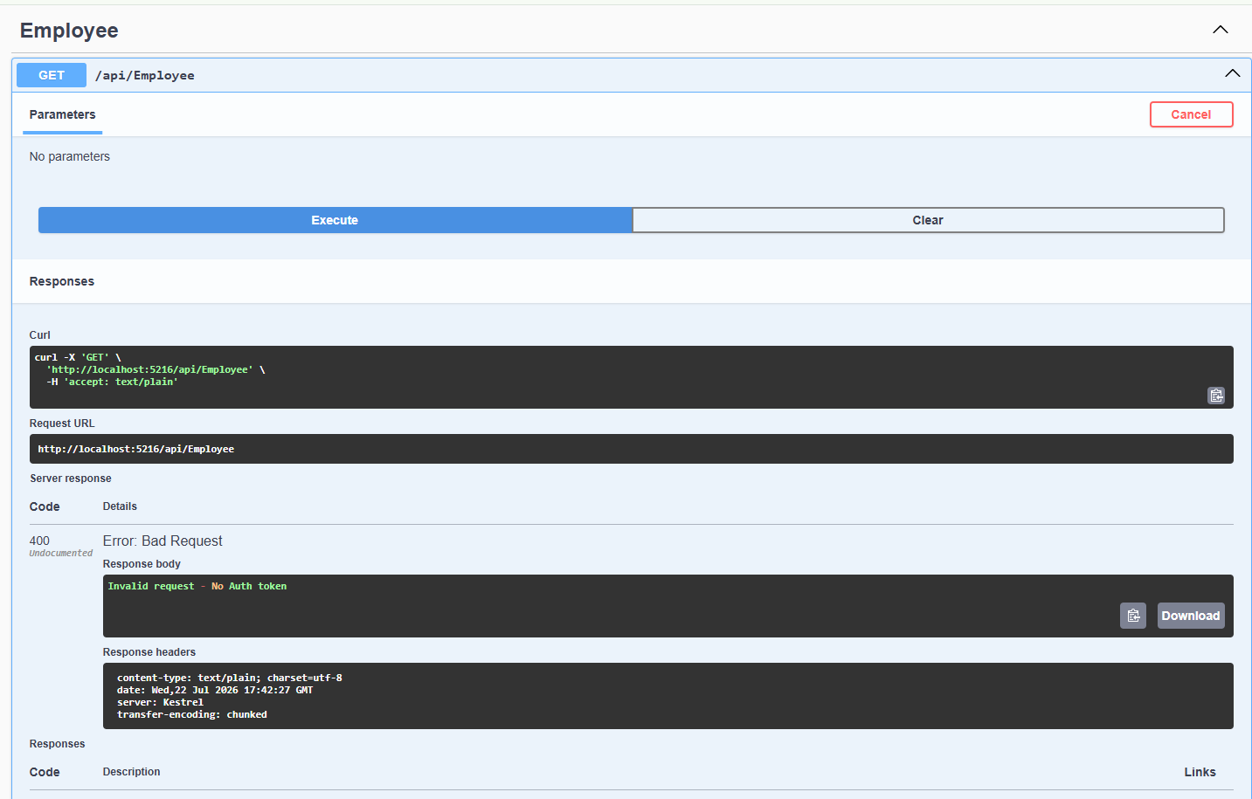
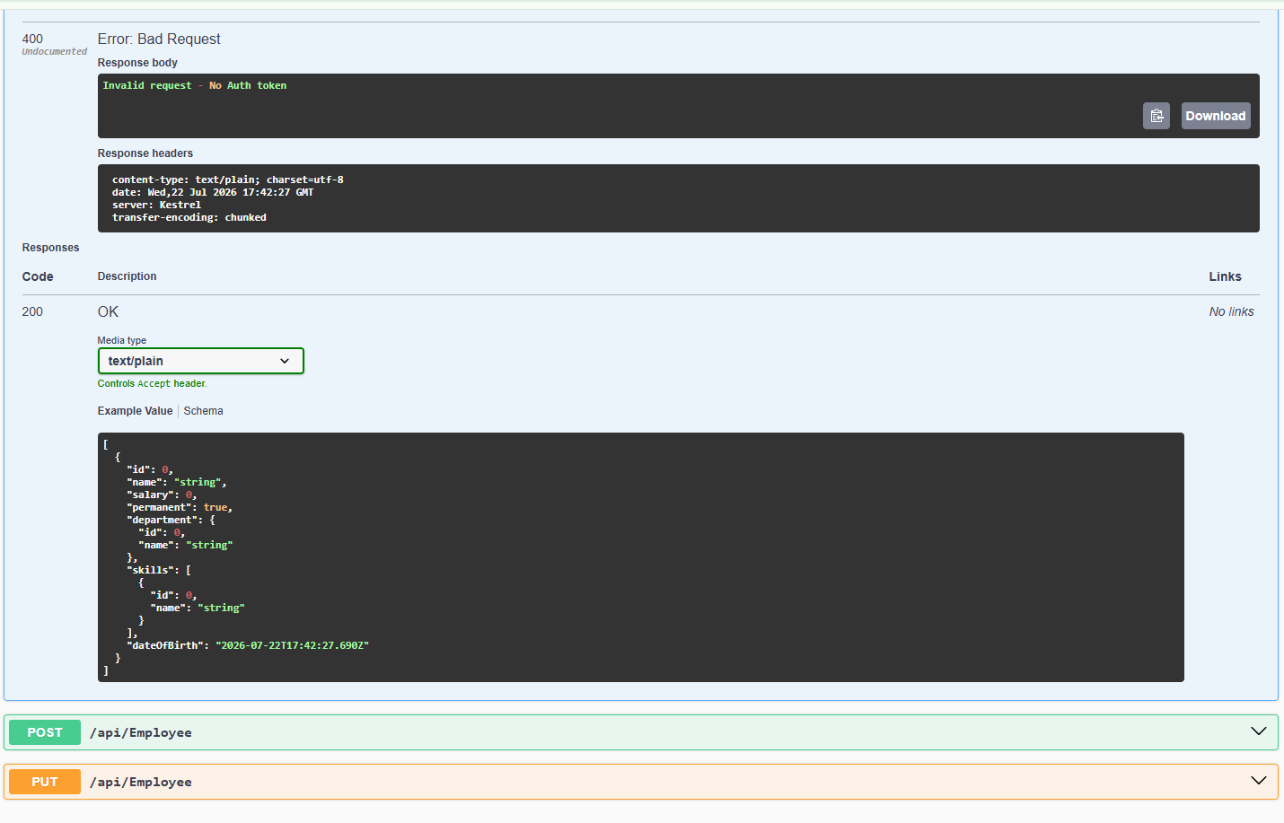

Custom Exception Filter – Internal Server Error

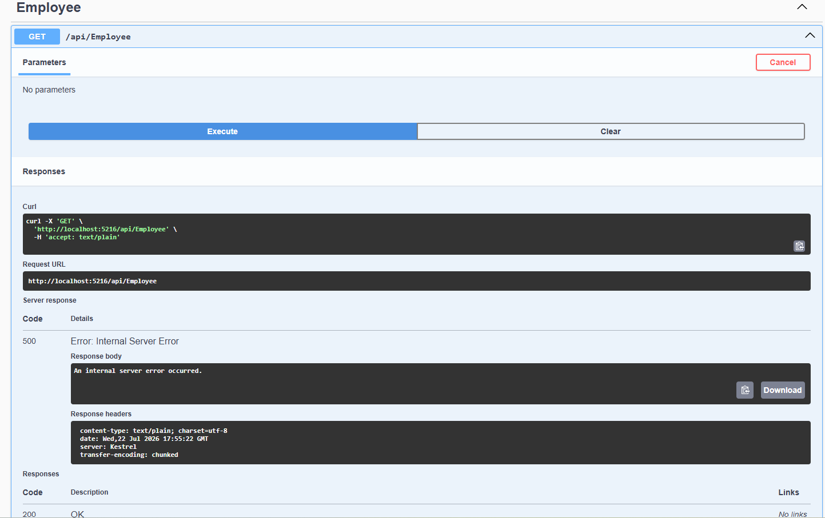

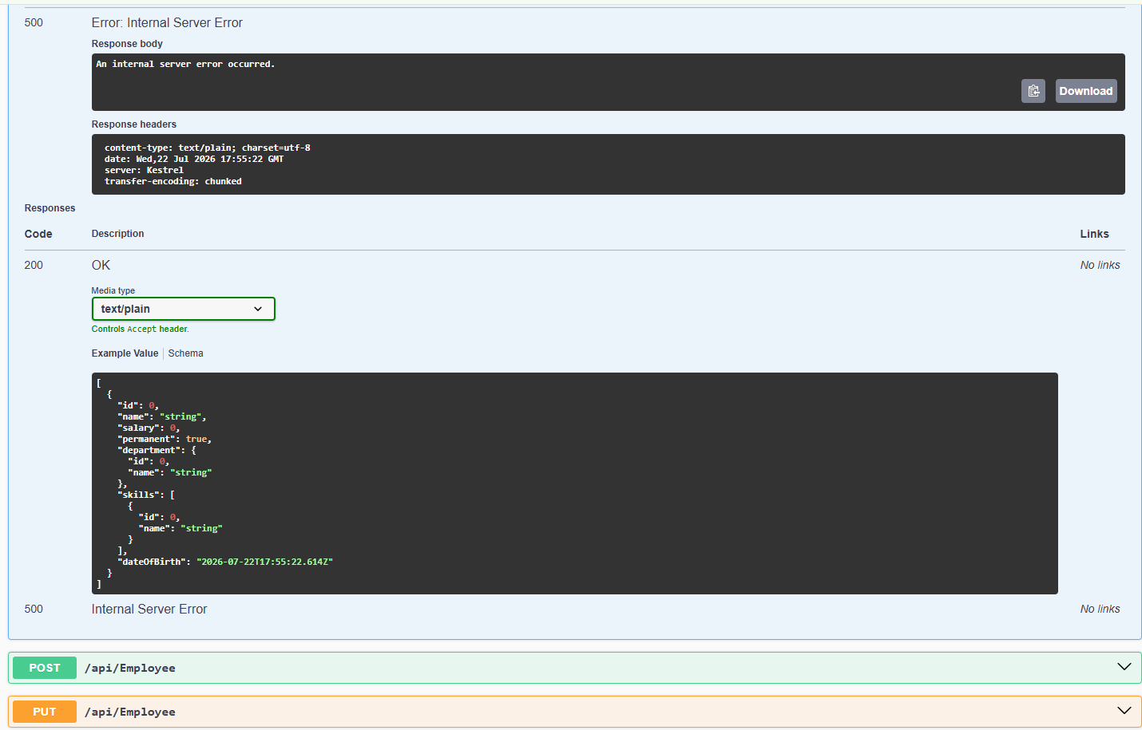

Exception Log
